CURRICULUM VITAE
PERSONAL PROFILE
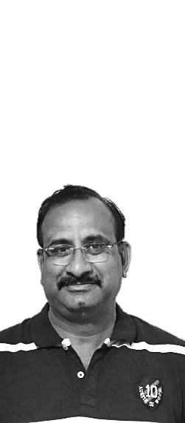
-----------------------------------------------------------------------------------------------------------------------------------------
Dr. K.G. Mallikarjuna, MA, MPhil., PhD., NET.,
Lecturer in Economics,
Government College for Men, Kurnool,
Constituent College of Cluster University,
Kurnool – 518004 (AP)
Email: mallik.eco@gmail.com
Mobile: 9494989773
Date of Birth: 02-04-1973
Languages known: Telugu, English, Hindi
-----------------------------------------------------------------------------------------------------------------------------------------
ACADEMIC PROFILE
-----------------------------------------------------------------------------------------------------------------------------------------
SN | Qualification | Specialization | % of Marks | College/University | Year
1 | SSC | General | 56 | Govt Town Model School, Knl | 1988
2 | Intermediate | HEC | 58 | Govt Jr. College, Knl | 1990
3 | BA | HEP | 64 | GDC (M), KNL | 1993
4 | MA | Economics | 65 | S V University, Tirupati | 1995
5 | MPhil | Energy Economics | 68 | S V University, Tirupati | 1997
6 | NET | Economics | --- | APCSC, HYD | 1997
7 | PhD | Agricultural Finance | --- | S K University, Anantapuram | 2009
-----------------------------------------------------------------------------------------------------------------------------------------
PROFESSIONAL PROFILE
-----------------------------------------------------------------------------------------------------------------------------------------
Date of initial appointment as Degree College Lecturer : 13.05.1997
Date of Grant-In-Aid : 18.03.2001
College where appointed : SBSYM Degree College, Kurnool (Aided)
Redeployment year : To GDC (M), Kurnool in 1997.
Absorbed into Government Services & appointed in : To GDC (M), Kurnool in 2021
Total teaching experience : 4 Yrs (Private), 20 Yrs (Aided & Govt)
-----------------------------------------------------------------------------------------------------------------------------------------
COURSES ATTENDED
-----------------------------------------------------------------------------------------------------------------------------------------
SN | COURSE | ORGANISED BY | PLACE | GRADE OBTAINED | YEAR
1 | OC | ASC, Osmania university | Hyderabad | A | 2004
2 | RC-Economics | ASC, Jamia Millia Islamia | New Delhi | A | 2005
3 | RC-Economics | ASC, Goa University | Goa | A | 2010
4 | RC-Economics | ASC, University of North Bengal | Darjeeling | A | 2011
5 | Workshop | CCE, HYD | Tirupati | --- | 2006
6 | FDP in LMS | APCCE, Vijayawada | Online | --- | 2020
7 | FDP in Economics | APCCE, Vijayawada | Online | --- | 2021
-----------------------------------------------------------------------------------------------------------------------------------------
PROFESSIONAL EFFICIENCY & RESEARCH
-----------------------------------------------------------------------------------------------------------------------------------------
Creation of Learning Management System : Created through Google Classroom, CANVAS,
TALENT, MOODLES, TEACHMINT Etc.
Articles published : 14 articles in International Journals.
Co-Director : International Seminar organized by Pol. Science.
Total YouTube Videos created : 33 Video lessons
Total Four-Quadrant material created for APCCE : 8 Modules
Created Departmental Website : http://mallik73.wixsite.com/economics
-----------------------------------------------------------------------------------------------------------------------------------------
ADDITIONAL RESPONSIBILITIES & ABILITIES
-----------------------------------------------------------------------------------------------------------------------------------------
NCC : ‘C’ – Certificate
In-charge of the Department of Economics : From 2018 to 2022.
In-charge of Department of Physical Education : From 2017 to 2019
In-charge of Department of Statistics : From 2019 to 2021
NIRF : Convener
NAAC Committee : Member
IQAC : Member
Newsletter Committee : Convener

******

